

**SAVEETHA SCHOOL OF ENGINEERING**

**SAVEETHA INSTITUTE OF MEDICAL AND TECHNICAL SCIENCES**

**CAPSTONE PROJECT REPORT**

**PROJECT TITLE**

**Impact of Inventory Management system on the sales of E-Commerce**

**DSA0511-Query Processing for Data Science with Sentiment Analysis**

Submitted

By

**MAHESH M (192224092)**

Guided by

V.Saranya

Junior Research Fellow

Department of Neural Networks

**Table of CONTENTS:**

|  |  |  |
| --- | --- | --- |
| **S.NO** | **TOPIC** | **PAGE NO** |
| **1** | **ABSTRACT** | **4** |
| **2** | **INTRODUCTION** | **4** |
| **3** | **Literature Review** | **5** |
| **4** | **Problem Statement** | **7** |
| **5** | **Environmental Setup** | **8** |
| **6** | **Methodology** | **10** |
| **7** | **Code Implementation** | **11** |
| **8** | **Output** | **13** |
| **9** | **Results And Discussion** | **14** |
| **10** | **Conclusion** | **14** |

**BONAFIDE CERTIFICATE**

Certified that this project report titled **“Impact of Inventory Management system on the sales of E-Commerce”** is the bonafide work of “**M. Mahesh(192224092)”**who carried out the project work. Certified further, that to the best of my knowledge the work reported herein does not form any other project report.

**DATE: Project Supervisor: Head of The Department:**

**ABSTRACT**

* Inventory control management systems (IMS) are essential for businesses across industries.
* IMS plays a crucial role in optimizing inventory levels and reducing costs.
* Leveraging automation and data analytics, IMS enables real-time tracking of inventory.
* IMS minimizes stockouts and overstock situations, enhancing operational efficiency.
* Improved order fulfillment accuracy through IMS enhances customer satisfaction and loyalty.

**INTRODUCTION**

* Inventory management refers to the process of ordering, storing, using, and selling a company's inventory.
* This includes the management of raw materials, components, and finished products, as well as warehousing and processing of such items.
* An Inventory Management System (IMS) is a software application that helps businesses track, manage, and organize their inventory levels, orders, sales, and deliveries.
* It enables companies to efficiently manage their stock, reducing the risk of overstocking or stockouts, thus optimizing operations and improving customer satisfaction.
* Inventory management is the entire process of managing inventories from raw materials to finished products.
* Inventory management tries to efficiently streamline inventories to avoid both glutes and shortages.

**LITERATURE REVIEW:**

|  |  |  |  |  |
| --- | --- | --- | --- | --- |
| **Title** | **Year** | **Objective** | **Advantages** | **Limitations** |
| **Impact of Stockout Compensation in E-Commerce Drop-Shipping Supply Chain** | 2020 | ● Investigate impact of stockout compensation strategies on supplier and retailer profits   * Analyze profit differences between E-SC, S-SC, and N-SC strategies   . | * E-SC and S-SC strategies increase profits in the e-commerce supply chain. * S-SC strategy can offset stockout compensation cost with slight price increase. | * High demand variability, low production capacity, and service level affect profits. * E-SC has less than 4.0% profit difference compared to N-SC. |
| **An Optimal Pricing and Inventory Control Policy for Online Sale** | 2022 | * Maximize average profit through optimal pricing and inventory control policy. * Develop an iterative algorithm to determine optimal price and order quantity. | * Maximize average profit * Improve sale profit through optimal pricing and inventory control | ● The study's theoretical emphasis may neglect real-world complexities  ●It overlooks sudden changes in consumer behavior and supply chain disruptions, affecting practical relevance |
| **Analysis of Behavioural Data of Customer for the E-Commerce Platform by using Machine Learning Approach** | 2023 | * Analyze customer purchase tendencies and improve product discoverability. * Use machine learning to classify customers and anticipate product sales. | ● Improves customer behavior, product discoverability, warehouse maintenance   * Anticipates e-commerce sales using machine learning techniques   . | * The collection and analysis of detailed behavioral data raise significant privacy and security concerns. * Machine learning models may suffer from overfitting and bias, leading to poor generalization and potentially unfair predictions. |

**PROBLEM STATEMENT**

Effective inventory management is critical for the operational efficiency and profitability of e-commerce businesses. In the case of Amazon Inc Several significant challenges have been identified in the current inventory management system, impacting sales performance and financial health.

The primary problems include:

**1.1Sales Fluctuations and Their Impact on Inventory:**

* **Least Sales Month:** Difficulty in predicting and preparing for months with the least sales, leading to potential overstocking and increased holding costs.
* **Peak Sales Month:** Inability to accurately forecast and manage inventory during peak sales months, causing stockouts and missed sales opportunities.

**1.2Stockouts and Overstocking:**

* **Stockouts:** Inadequate inventory levels during periods of unexpected high sales result in stockouts, damaging customer satisfaction and leading to lost sales.
* **Overstocking:** Excessive inventory due to low sales ties up capital, increases holding costs, and leads to potential obsolescence.

**1.3Carrying Costs During High Sales Periods:**

* High sales periods require holding more inventory, which escalates carrying costs. An efficient inventory management system must balance these costs with the benefits of meeting customer demand.

**1.4Seasonal Sales Adjustments:**

* Many e-commerce businesses, including Amazon, experience seasonal variations in sales. The current inventory management system struggles to adapt to these fluctuations, leading to misaligned inventory levels and suboptimal stock availability.

**ENVIRONMENTAL SETUP**

**Scope:**The scope of the inventory management system (IMS) project defines the specific boundaries and parameters within which the project will operate. It outlines what the project will deliver, the activities it will involve, and the limitations or exclusions.

**Data Sources:**Data sources for an inventory management system (IMS) are critical as they provide the information needed to track, manage, and optimize inventory levels, orders, sales, and deliveries.

**Data Analysis:**Data analysis in an inventory management system (IMS) involves examining and interpreting the data collected from various sources to make informed decisions, optimize inventory levels, and improve operational efficiency.

### **Data Collection and Integration**

#### **Data Aggregation**

* Collect data from various internal and external sources (ERP, POS, WMS, suppliers, IoT devices).
* Integrate data into a centralized database or data warehouse for unified analysis.

#### **Data Cleaning**

* Remove duplicates, correct errors, and handle missing values to ensure data quality.
* Standardize data formats for consistency.

Data analysis in an IMS provides valuable insights that help in making data-driven decisions to optimize inventory levels, reduce costs, and improve overall efficiency. By leveraging descriptive, diagnostic, predictive, and prescriptive analytics, businesses can enhance their inventory management practices and achieve better outcomes.

**DATA FLOW DIAGRAM**

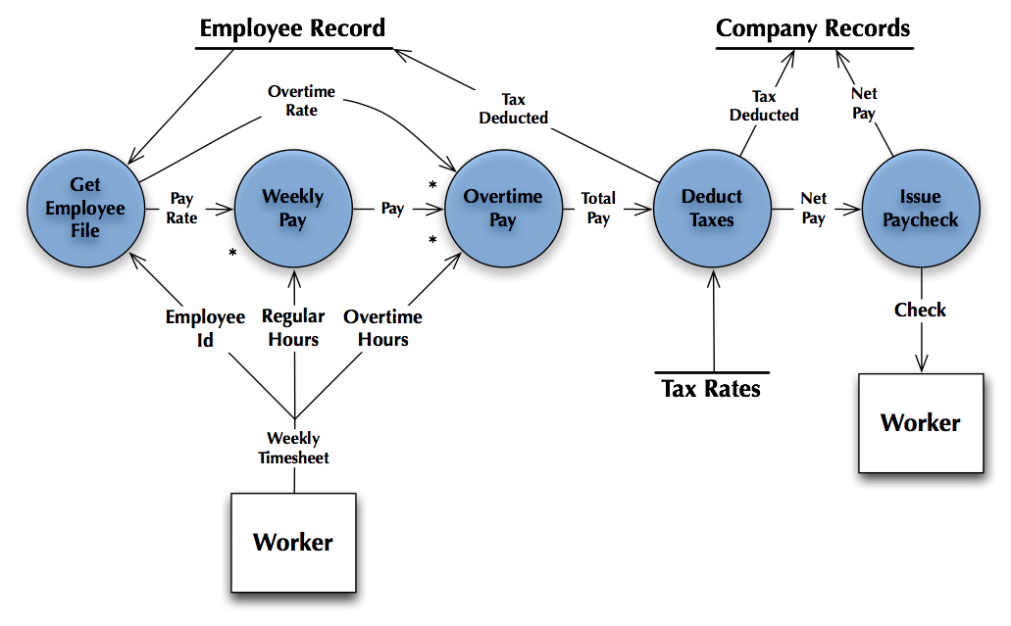

Flow diagram on inventory management

**METHODOLOGY**

**Real-Time Inventory Tracking:**

Continuously updated inventory levels instantly as transactions occur, ensuring that inventory data is always accurate and up-to-date for efficient inventory management and decision-making.

**Performs Stock Counts:**

Conducts accurate and periodic physical counts of inventory to verify and reconcile system data with actual stock levels, helping to identify discrepancies and maintain inventory accuracy.

**Stock Projections:**

Predicts future inventory needs based on historical data, trends, and demand forecasting, enabling businesses to plan inventory purchases and avoid stockouts or overstock situations.

**Inventory Reports and Analytics:**

Generates detailed reports and insights on inventory performance, turnover rates, and trends, providing valuable information for strategic planning, cost control, and optimizing inventory levels.

**Integration with Other Tools:**

Seamlessly connects with other business applications like ERP, CRM, and e-commerce platforms, ensuring smooth data flow across systems, improving efficiency, and reducing manual data entry errors.

**INVENTORY MANAGEMENT TECHNIQUES**

**Just-in-Time Management (JIT):**Minimizing inventory levels by receiving goods only as they are needed.

**Materials Requirement Planning (MRP):**This inventory management method is sales-forecast dependent, meaning that manufacturers must have accurate sales records to enable accurate planning of inventory needs and to communicate those needs with materials suppliers in a timely manner.

**Economic Order Quantity (EOQ):**Calculating the optimal order quantity to minimize total inventory costs.

**Days Sales of Inventory (DSI):**Indicating the liquidity of the inventory, the figure represents how many days a company’s current stock of inventory will last

**CODE IMPLEMENTATION**

import pandas as pd

import matplotlib.pyplot as plt

import numpy as np

data_past = {

'Month': ['Jan', 'Feb', 'Mar', 'Apr', 'May'],

'Stock_Sold': [100, 150, 120, 130, 140],

'Stock_Ordered': [120, 170, 130, 140, 160],

'Stock_Wasted': [20, 25, 15, 10, 20],

'Delivered_On_Time': [80, 85, 90, 88, 82],

'Customer_Need_Met': [70, 75, 80, 78, 72]

}

data_after = {

'Month': ['Jan', 'Feb', 'Mar', 'Apr', 'May'],

'Stock_Sold': [110, 160, 130, 140, 150],

'Stock_Ordered': [115, 165, 125, 135, 150],

'Stock_Wasted': [5, 8, 3, 2, 5],

'Delivered_On_Time': [90, 92, 95, 93, 90],

'Customer_Need_Met': [85, 88, 90, 92, 88]

}

df_past = pd.DataFrame(data_past)

df_after = pd.DataFrame(data_after)

colors = ['blue', 'green']

plt.figure(figsize=(12, 8))

stock_metrics = ['Stock_Sold', 'Stock_Ordered', 'Stock_Wasted']

for i, metric in enumerate(stock_metrics):

plt.subplot(2, 2, i+1)

plt.bar(df_past['Month'], df_past[metric], color=colors[0], width=0.4, align='center', label='Past')

plt.bar(df_after['Month'], df_after[metric], color=colors[1], width=0.4, align='edge', label='After')

plt.title(f'Comparison of {metric} Before and After Implementing Inventory Control')

plt.xlabel('Month')

plt.ylabel(metric)

plt.legend()

plt.tight_layout(rect=[0, 0, 1, 0.96])

plt.suptitle('Stock-Related Metrics Comparison', fontsize=16)

plt.show()

plt.figure(figsize=(12, 8))

service_metrics = ['Delivered_On_Time', 'Customer_Need_Met']

for i, metric in enumerate(service_metrics):

plt.subplot(2, 1, i+1)

plt.bar(df_past['Month'], df_past[metric], color=colors[0], width=0.4, align='center', label='Past')

plt.bar(df_after['Month'], df_after[metric], color=colors[1], width=0.4, align='edge', label='After')

plt.title(f'Comparison of {metric} Before and After Implementing Inventory Control')

plt.xlabel('Month')

plt.ylabel(metric)

plt.legend()

plt.grid(axis='y', linestyle='--', linewidth=0.7)

plt.tight_layout(rect=[0, 0, 1, 0.96])

plt.suptitle('Service-Related Metrics Comparison', fontsize=16)

plt.show()

**OUTPUT**

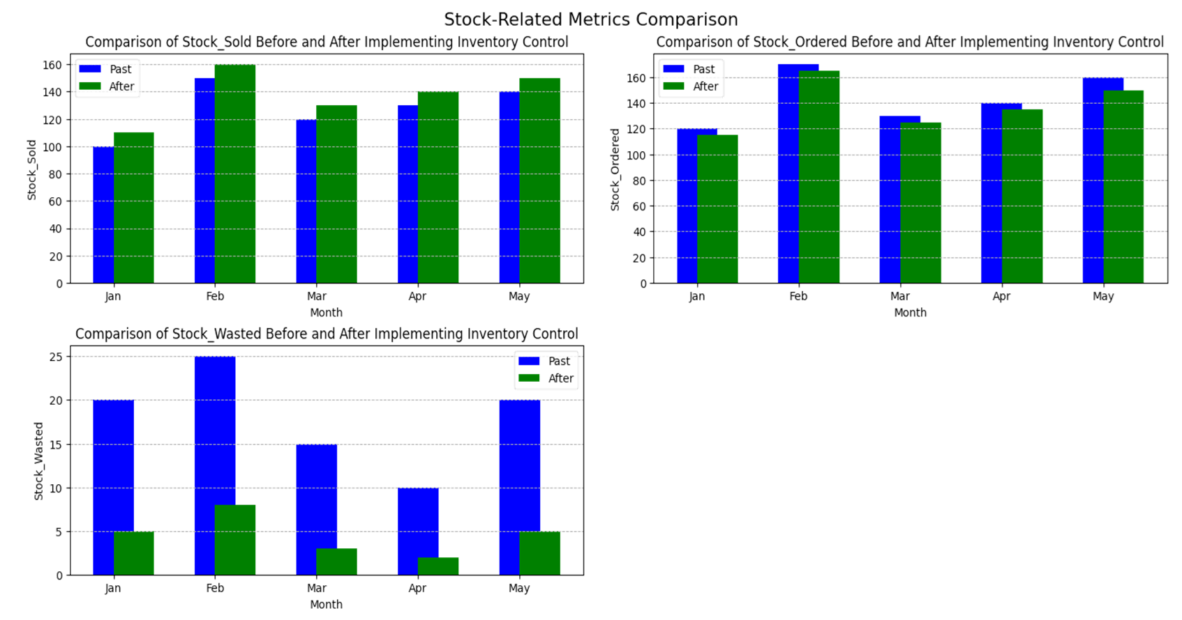

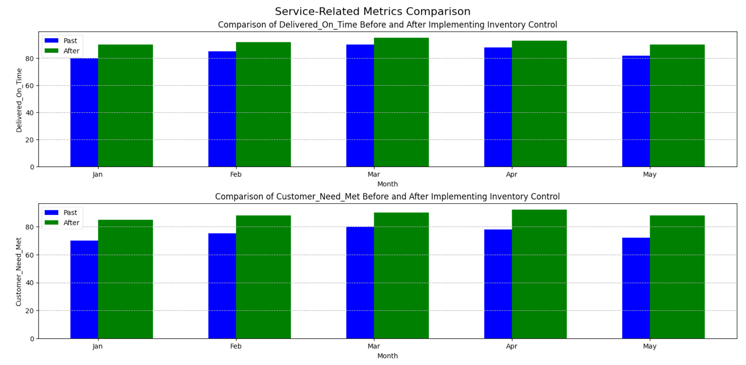

**RESULTS AND DISCUSSION**

* The Inventory Control Management System was successfully implemented, including modules for inventory tracking, order management, supplier management, and reporting. Key functionalities such as real-time inventory updates, automated reorder alerts, and detailed analytics were tested and validated.
* Having accurate inventory data and better forecasting capabilities, the company could negotiate better terms with suppliers and take advantage of bulk purchasing discounts without overstocking.
* Improved order accuracy and a significant reduction in customer complaints underscore the positive impact of the ICMS on customer satisfaction.
* The increase in the inventory turnover ratio indicates more efficient inventory management.
* The significant reduction in waste is a notable achievement, reflecting better demand forecasting and more efficient inventory management.
* This contributes positively to sustainability goals and reduces disposal costs.

**CONCLUSION**

An e-commerce store’s inventory is its lifeblood. Backorders are avoided, consumers are satisfied, and your firm is lucrative when you have the right products in stock. By streamlining and automating inventory control operations, optimizing your logistic cycle, and providing you with a real-time picture of stock levels, a robust inventory management system may help you save time and money.